

|  |  |  |  |  |  |  |  |  |
| --- | --- | --- | --- | --- | --- | --- | --- | --- |
|  | | | | | | | | |
|  | | Project On Tata Power Stock Analysis | | | | |  | |
|  |  | | | | | | |  |
|  | | | |  |  | | | |
|  | | | | Sampath Yadav |  | | | |
|  | | | | SmartBridge Educational Services Private Limited—Data Analytics—Project Guide :- Srikanth |  | | | |
|  | | |  | | |  | | |

Project Overview: -

Overview of Tata Power Stock Dataset:

The Tata Power Company Limited (Tata Power) is an Indian electric utility company and a subsidiary of the Tata Group conglomerate. It is one of the largest integrated power companies in India, generating, transmitting, and distributing electricity across various regions. The Tata Power stock dataset provides historical data and information related to the company's stock performance in the financial markets.

Key Features of the Dataset:

1. Stock Price Data: The dataset includes historical stock price information for Tata Power, typically presented in the form of daily closing prices. It enables analysis and tracking of the stock's price movements over a specific time period.

2. Time Frame: The dataset covers a specific time range, which could vary depending on the source and availability of the data. It may include data spanning several years or a shorter period, allowing users to analyze both long-term and short-term trends.

3. Stock Metrics: Along with stock prices, the dataset may include additional metrics such as trading volume, market capitalization, dividend information, and other relevant financial indicators. These metrics provide insights into the company's financial health and investor sentiment.

4. Data Granularity: The dataset may provide data at various levels of granularity, such as daily, weekly, monthly, or even intraday intervals. The availability of data at different time intervals allows users to analyze the stock's performance with different perspectives.

5. Adjacent Market Data: In addition to the stock-specific information, the dataset may also include relevant market indices or sector indices to provide a benchmark for comparison. This allows users to assess the relative performance of Tata Power's stock against broader market trends.

6. Data Sources: The dataset may be compiled from various sources, including stock exchanges, financial data providers, or reputable financial websites. It is essential to ensure the reliability and accuracy of the data sources to maintain data integrity.

Potential Use Cases:

1. Stock Performance Analysis: The dataset enables users to analyze the historical performance of Tata Power's stock, identify patterns, and study the impact of various factors on its price movement. This analysis can be valuable for investors, traders, and financial analysts.

2. Technical Analysis: Traders can utilize the dataset for technical analysis purposes, employing various indicators, chart patterns, and statistical tools to predict future price movements and make informed trading decisions.

3. Financial Research: Researchers can leverage the dataset to conduct empirical studies on stock market dynamics, correlations with macroeconomic variables, or explore relationships with other companies or sectors.

4. Algorithmic Trading: Quantitative analysts and algorithmic traders can use the dataset to develop and backtest trading strategies based on historical price patterns and related metrics.

5. Machine Learning Models: Data scientists can employ the dataset to build machine learning models that predict future stock prices or identify trading signals based on historical patterns and additional factors.

It is important to note that the dataset's usefulness and relevance depend on its quality, completeness, and timeliness. Users should exercise due diligence in understanding the dataset's limitations and verifying its accuracy when using it for analysis or decision-making.

**Technical Architecture:-**

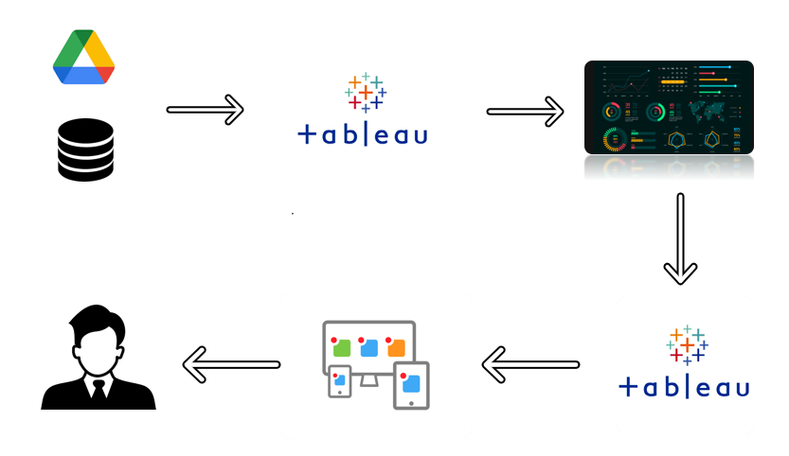

**Project Flow**

To accomplish this, we have to complete all the activities listed below,

Define Problem / Problem Understanding

* + Specify the business problem
  + Business requirements
  + Literature Survey
  + Social or Business Impact.
* Data Collection & Extraction from Database
  + Collect the dataset,
  + Connect dataset with Tableau
* Data Preparation
  + Prepare the Data for Visualization
* Data Visualizations
  + No of Unique Visualizations
* Dashboard
  + Responsive and Design of Dashboard
* Story
  + No of Scenes of Story
* Performance Testing
  + Amount of Data Rendered to DB ‘
  + Utilization of Data Filters
  + No of Calculation Fields
  + No of Visualizations/ Graphs
* Web Integration
  + Dashboard and Story embed with UI With Flask
* Project Demonstration & Documentation
  + Record explanation Video for project end to end solution.
  + Project Documentation-Step by step project development procedure

**Milestone 1: Define Problem / Problem Understanding**

**Activity 1: Specify the business problem**

Refer Project Description

**Activity 2: Business requirements**

The business requirements for this project would likely include

Data collection: The first requirement is to collect data from a datasource that is relevant to Artificial Intelligence.

Data cleaning and preparation: The collected data must be cleaned and processed to ensure it is suitable for analysis. This may involve removing irrelevant information, correcting inconsistencies and missing values, and transforming the data into a format that is compatible with the analysis tools.

Data analysis: The data must be analysed to uncover meaningful insights.This could involve using techniques such as descriptive statistics, regression analysis, and data visualization to gain a deeper understanding of the data.

Report creation: The insights and findings from the data analysis must be presented in a comprehensive report that includes visualizations and data tables. The report must be well organized and easy to understand, with clear and concise explanations of the results.

**Activity 3: Literature Survey :-**

**Literature Review on Tata Power Stock Dataset:**

**1. "Stock Market Prediction using Machine Learning Techniques: A Review" by S. Gurung and S. Ghimire (2020):This study provides a comprehensive review of machine learning techniques applied to stock market prediction. It discusses various algorithms and models used for forecasting stock prices, including those applied to Tata Power stock. The authors highlight the importance of accurate and reliable datasets, such as the Tata Power stock dataset, for training and evaluating machine learning models.**

**2. "Predicting Stock Prices using Technical Analysis and Machine Learning Techniques" by P. Gupta and R. Rastogi (2020):The paper explores the prediction of stock prices using both technical analysis indicators and machine learning techniques. It includes an analysis of Tata Power stock data and compares the performance of different machine learning algorithms in predicting future stock prices. The study emphasizes the significance of accurate and comprehensive datasets in achieving reliable predictions.**

**3. "An Empirical Study on Factors Affecting Stock Returns in Indian Power Sector" by S. Prasad and S. Swarup (2019):This research focuses on the factors influencing stock returns in the Indian power sector, including Tata Power. It analyzes various fundamental and market-related factors and their impact on stock performance. The study utilizes historical stock price data from Tata Power and other companies to conduct a comprehensive empirical analysis.**

**4. "Efficiency of Indian Stock Market: A Study of Power Sector" by P. Singh and S. Gupta (2018):The paper examines the efficiency of the Indian stock market, particularly within the power sector. It analyzes the Tata Power stock data and other power sector stocks to determine market efficiency and the presence of any anomalies. The study utilizes statistical measures and econometric models to evaluate stock market efficiency.**

**5. "Volatility Spillovers and Stock Market Linkages: Evidence from India's Power Sector" by S. Patnaik and R. Jain (2017):This research investigates the volatility spillovers and stock market linkages within India's power sector. The study examines the interrelationships between Tata Power stock and other power sector stocks to understand the transmission of market volatility. It utilizes time series analysis techniques and examines the co-movement of stock prices in the sector.**

**6. "A Comparative Analysis of Stock Market Prediction using Data Mining Techniques" by S. Bhatia and V. Sethi (2016):The paper provides a comparative analysis of various data mining techniques for stock market prediction, including those applied to Tata Power stock. It explores the use of historical stock price data, along with other financial and market indicators, to develop predictive models. The study evaluates the performance of different algorithms and discusses the importance of accurate and comprehensive datasets.**

**These literature reviews highlight the importance of accurate and reliable datasets, such as the Tata Power stock dataset, for various applications, including stock prediction, market efficiency analysis, and empirical studies. Researchers emphasize the need for robust datasets to ensure the validity and credibility of their analyses and models.**

**Activity 4: Social or Business Impact.**

**Business Model/Impact**: -

**1. Investment Decision-making: The Tata Power stock dataset provides valuable information for investors and financial institutions in making informed investment decisions. It enables investors to assess the historical performance, volatility, and trends of Tata Power stock. This dataset aids in evaluating the company's financial health, market position, and growth prospects, which are crucial factors for investment analysis.**

**2. Risk Management: The availability of historical stock data allows risk managers and portfolio managers to analyze the risk-return profile of Tata Power stock. They can use the dataset to assess the volatility, correlations, and downside risks associated with investing in Tata Power. This information helps in constructing diversified portfolios and managing risks effectively.**

**3. Market Analysis and Strategy: Financial analysts and market researchers utilize the Tata Power stock dataset to conduct market analysis and formulate investment strategies. By studying the historical data, market trends, and correlations with other market indicators, analysts can identify patterns, market cycles, and potential trading opportunities. This dataset aids in developing investment strategies aligned with market dynamics.**

**4. Algorithmic Trading and Quantitative Research: The availability of the Tata Power stock dataset is valuable for quantitative analysts and algorithmic traders. They can use the historical data to develop and backtest trading strategies based on technical indicators, statistical models, and machine learning algorithms. This dataset supports the development of automated trading systems and quantitative research in the financial markets.**

**Social Impact:**

**1. Investor Education and Financial Literacy: The availability of the Tata Power stock dataset contributes to investor education and financial literacy. It allows individuals, students, and novice investors to understand the dynamics of stock markets, learn about investment strategies, and analyze real-world stock data. This promotes financial literacy and empowers individuals to make informed investment decisions.**

**2. Transparency and Accountability: The availability of accurate and comprehensive stock datasets, including Tata Power, promotes transparency and accountability in the financial markets. Investors and stakeholders can access reliable information about the company's historical performance, facilitating transparency in corporate operations. This fosters trust and confidence among investors and the general public.**

**3. Economic Analysis: The Tata Power stock dataset contributes to economic analysis by researchers, policymakers, and economists. By examining the stock's performance and correlations with macroeconomic variables, they can gain insights into the power sector's impact on the overall economy. This dataset aids in analyzing industry trends, policy implications, and the sector's contribution to economic growth.**

**4. Socio-economic Development: Tata Power plays a significant role in the power sector, contributing to the socio-economic development of the regions it serves. The stock dataset provides insights into the company's financial performance, expansion plans, and investment activities. This information helps policymakers, stakeholders, and communities assess the company's contribution to employment generation, infrastructure development, and overall economic progress.**

**Overall, the Tata Power stock dataset has substantial business implications, supporting investment decisions, risk management, market analysis, and quantitative research. Additionally, it contributes to social impacts, including investor education, transparency, economic analysis, and socio-economic development.**

**Milestone 2: Data Collection & Extraction from Database**

**Data collection is the process of gathering and measuring information on variables of interest, in an established systematic fashion that enables one to answer stated research questions, test hypotheses, and evaluate outcomes and generate insights from the data.**

**Activity 1: Collect the dataset**

Please use the link to download the dataset:

<https://www.kaggle.com/datasets/ved1104/stocks>

**Activity 1.1: Understand the data.**

Check the below link out to understand the dataset in detail:

**Activity 2: Connect Dataset to Tableau**

Explanation video link:

<https://dexterit-my.sharepoint.com/:v:/g/personal/sam_dexterit_onmicrosoft_com/EQCDUCpNDupDp8ze_Pc9gNgBsQhlifLrZ4HHw0V2-Yvb4Q?e=dkGBwq>

**Milestone 3: Data Preparation**

**Activity 1: Prepare the Data for Visualization**

**Preparing the data for visualization involves cleaning the data to remove irrelevant or missing data, transforming the data into a format that can be easily visualized, exploring the data to identify patterns and trends, filtering the data to focus on specific subsets of data, preparing the data for visualization software, and ensuring the data is accurate and complete. This process helps to make the data easily understandable and ready for creating visualizations to gain insights into the performance and efficiency.**

* **Activity 1.1** : **Preparing a Data Module**:

<https://dexterit-my.sharepoint.com/:v:/g/personal/sam_dexterit_onmicrosoft_com/EQCDUCpNDupDp8ze_Pc9gNgBsQhlifLrZ4HHw0V2-Yvb4Q?e=dkGBwq>

**Milestone 4: Data Visualization**

**Data visualization is the process of creating graphical representations of data in order to help people understand and explore the information. The goal of data visualization is to make complex data sets more accessible, intuitive, and easier to interpret. By using visual elements such as charts, graphs, and maps, data visualizations can help people quickly identify patterns, trends, and outliers in the data.**

**Activity 1: No of Unique Visualizations**

**The number of unique visualizations that can be created with a given dataset. Some common types of visualizations that can be used to analyse the Rice production include bar charts, line charts, heat maps, scatter plots, pie charts,Maps etc. These visualizations can be used to compare performance, track changes over time, show distribution, and relationships between variables.**

**Activity 1.1:** **Sum** **Of Open & Close For Each Month**

**Explanation video link:** <https://dexterit-my.sharepoint.com/:v:/g/personal/sam_dexterit_onmicrosoft_com/EYxHv-FMd-dOh5f2-rOC3xoB9J26JRohMlp4lb6cDgksRg?e=ylDBxQ>

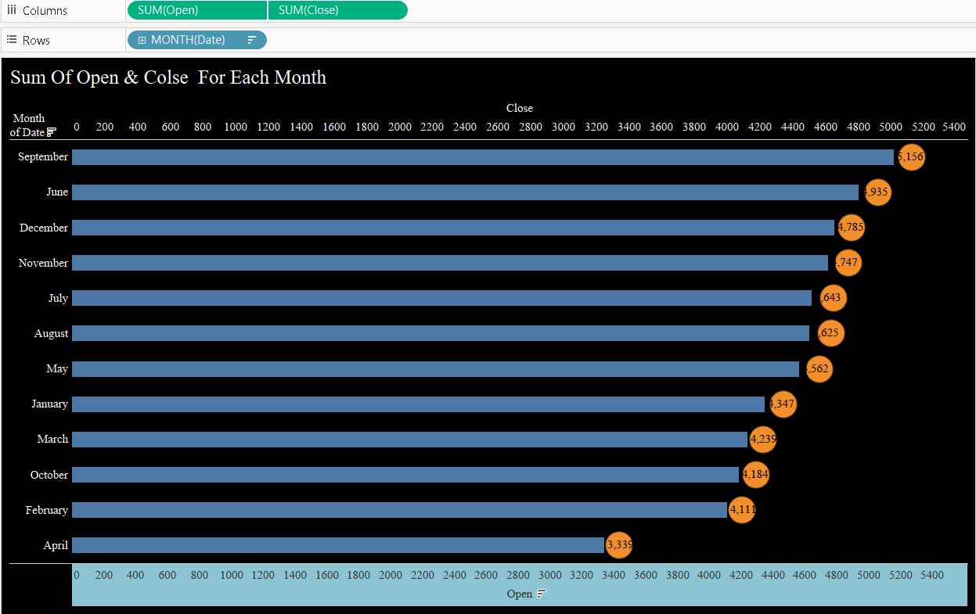

**Activity 1.2: Avg Of Each Date Quarter**

**Explanation video link:** [**https://dexterit-my.sharepoint.com/:v:/g/personal/sam_dexterit_onmicrosoft_com/EUWI-ax8eihMsNsVHP0N0eIBA-e5ttO3IRoHLrRYqGflHA?e=mTM3mM**](https://dexterit-my.sharepoint.com/:v:/g/personal/sam_dexterit_onmicrosoft_com/EUWI-ax8eihMsNsVHP0N0eIBA-e5ttO3IRoHLrRYqGflHA?e=mTM3mM)

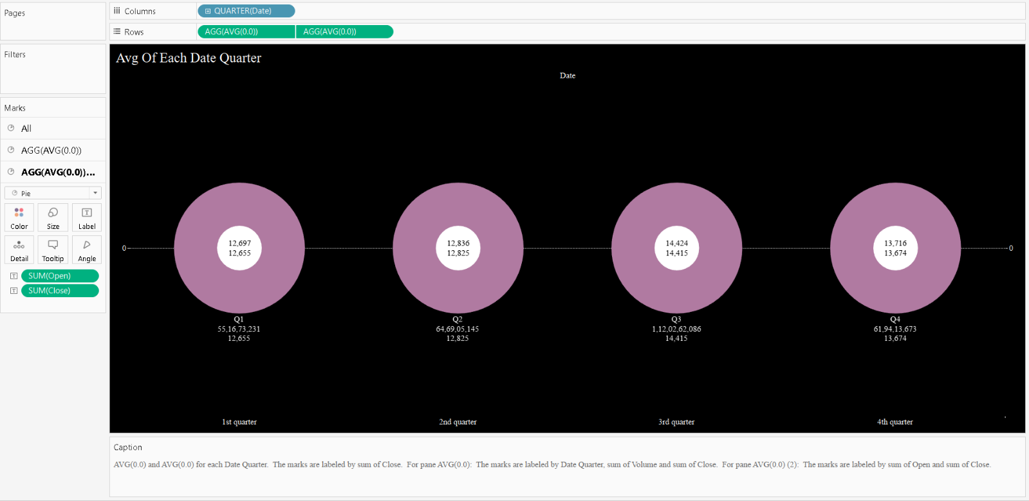

**Activity 1.3:** **The trends of Avg. Open and Close for Date Day**

**Explanation video link:** [**https://dexterit-my.sharepoint.com/:v:/g/personal/sam_dexterit_onmicrosoft_com/Ea6x4NfISWZIkrOiv7_9BPsBSsenzzx5FrobyWdYCf89aA?e=8rFhlI**](https://dexterit-my.sharepoint.com/:v:/g/personal/sam_dexterit_onmicrosoft_com/Ea6x4NfISWZIkrOiv7_9BPsBSsenzzx5FrobyWdYCf89aA?e=8rFhlI)

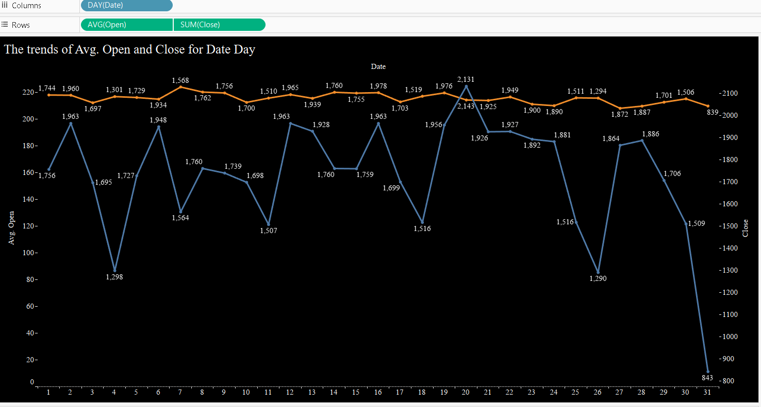

**Activity 1.4: Date Month, sum of Open and sum of Close**

**Explanation video link:** [**https://dexterit-my.sharepoint.com/:v:/g/personal/sam_dexterit_onmicrosoft_com/ETZ25-pAD0RKte1larvx9QIBKcQdnQuGQTo1Zg2qTh1N8Q?e=NbkYXR**](https://dexterit-my.sharepoint.com/:v:/g/personal/sam_dexterit_onmicrosoft_com/ETZ25-pAD0RKte1larvx9QIBKcQdnQuGQTo1Zg2qTh1N8Q?e=NbkYXR)

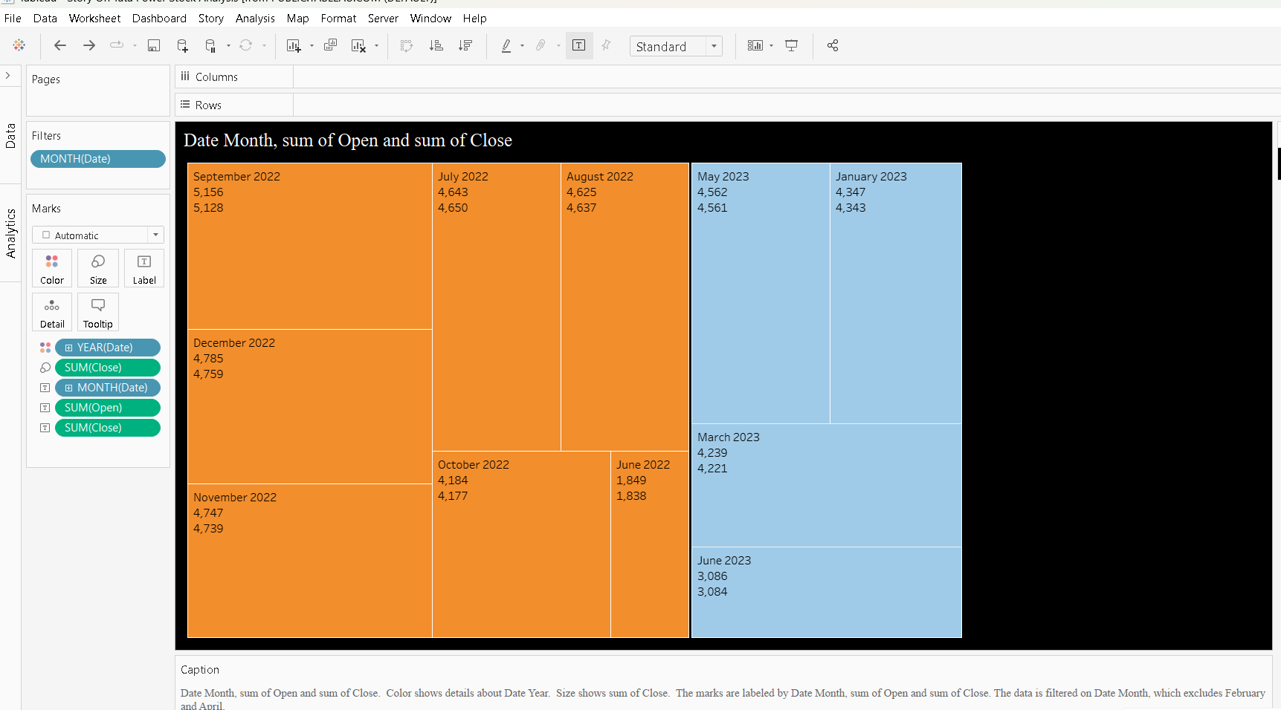

**Activity 1.5: AVG(0), sum of High and sum of Low for each Date Month**

**Explanation video link:** [**https://dexterit-my.sharepoint.com/:v:/g/personal/sam_dexterit_onmicrosoft_com/ETvsHo4NJTFGrb4ZColbTigBAQ9DJeJm0jjSOUU9a94HzA?e=I2CUSn**](https://dexterit-my.sharepoint.com/:v:/g/personal/sam_dexterit_onmicrosoft_com/ETvsHo4NJTFGrb4ZColbTigBAQ9DJeJm0jjSOUU9a94HzA?e=I2CUSn)

**Activity 1.6: High and Low for each Date Month**

**Explanation video link:**[**https://dexterit-my.sharepoint.com/:v:/g/personal/sam_dexterit_onmicrosoft_com/EcKWvc4ToStAkA2WoWD3D1YB9aHfmdrGVZkT2n94Z06rNA?e=cXhT7O**](https://dexterit-my.sharepoint.com/:v:/g/personal/sam_dexterit_onmicrosoft_com/EcKWvc4ToStAkA2WoWD3D1YB9aHfmdrGVZkT2n94Z06rNA?e=cXhT7O)

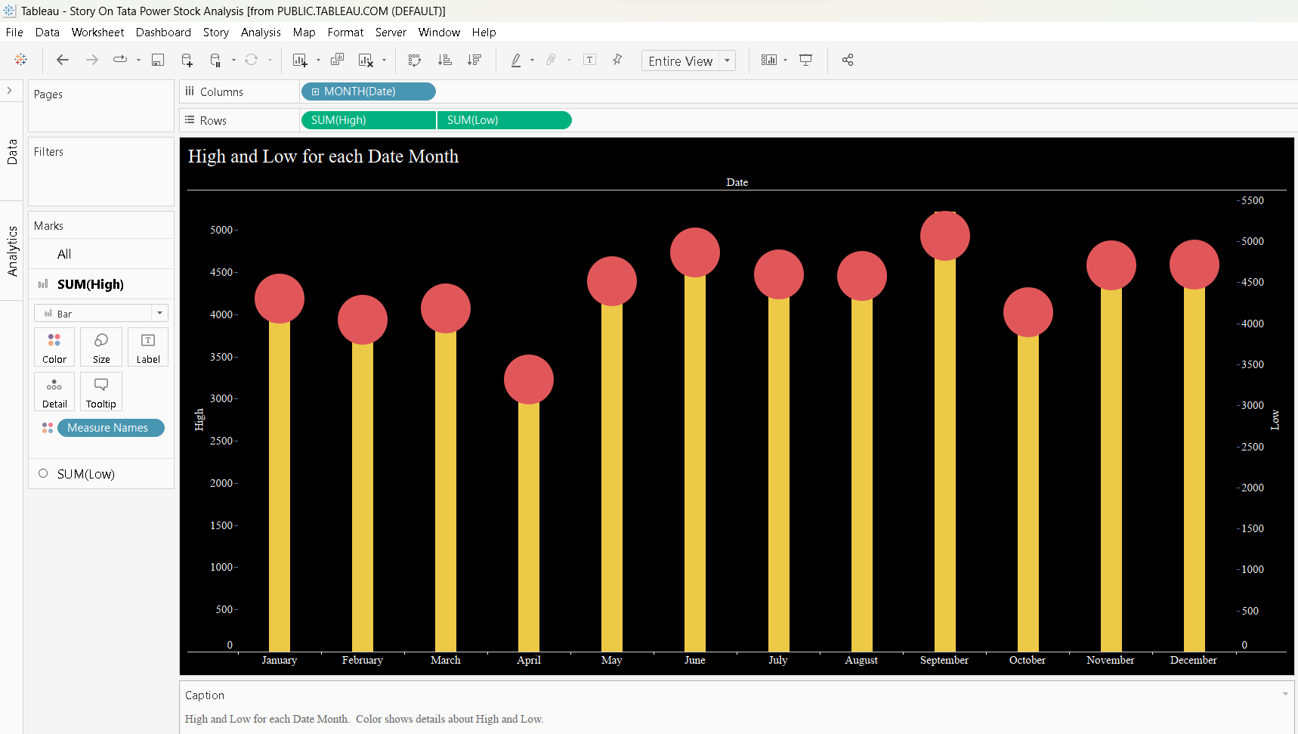

**Milestone 5: Dashboard**

A dashboard is a graphical user interface (GUI) that displays information and data in an organized, easy-to-read format. Dashboards are often used to provide real-time monitoring and analysis of data, and are typically designed for a specific purpose or use case. Dashboards can be used in a variety of settings, such as business, finance, manufacturing, healthcare, and many other industries. They can be used to track key performance indicators (KPIs), monitor performance metrics, and display data in the form of charts, graphs, and tables.

**Activity :1- Responsive and Design of Dashboard**

The responsiveness and design of a dashboard for analysing the factors important for Stock investors to invest in the Tata Power Stock analyzes various engagement metrics such as likes, high, Low And Open, close Of Stocks . We can also help in distributing the production across different countries.

**Explanation video link:-**

[**https://dexterit-my.sharepoint.com/:v:/g/personal/sam_dexterit_onmicrosoft_com/EcD597MpzslPrFkmb6iGCVgB0kBpIuucb9IiF-d_42HKAA?e=yD5aQn**](https://dexterit-my.sharepoint.com/:v:/g/personal/sam_dexterit_onmicrosoft_com/EcD597MpzslPrFkmb6iGCVgB0kBpIuucb9IiF-d_42HKAA?e=yD5aQn)

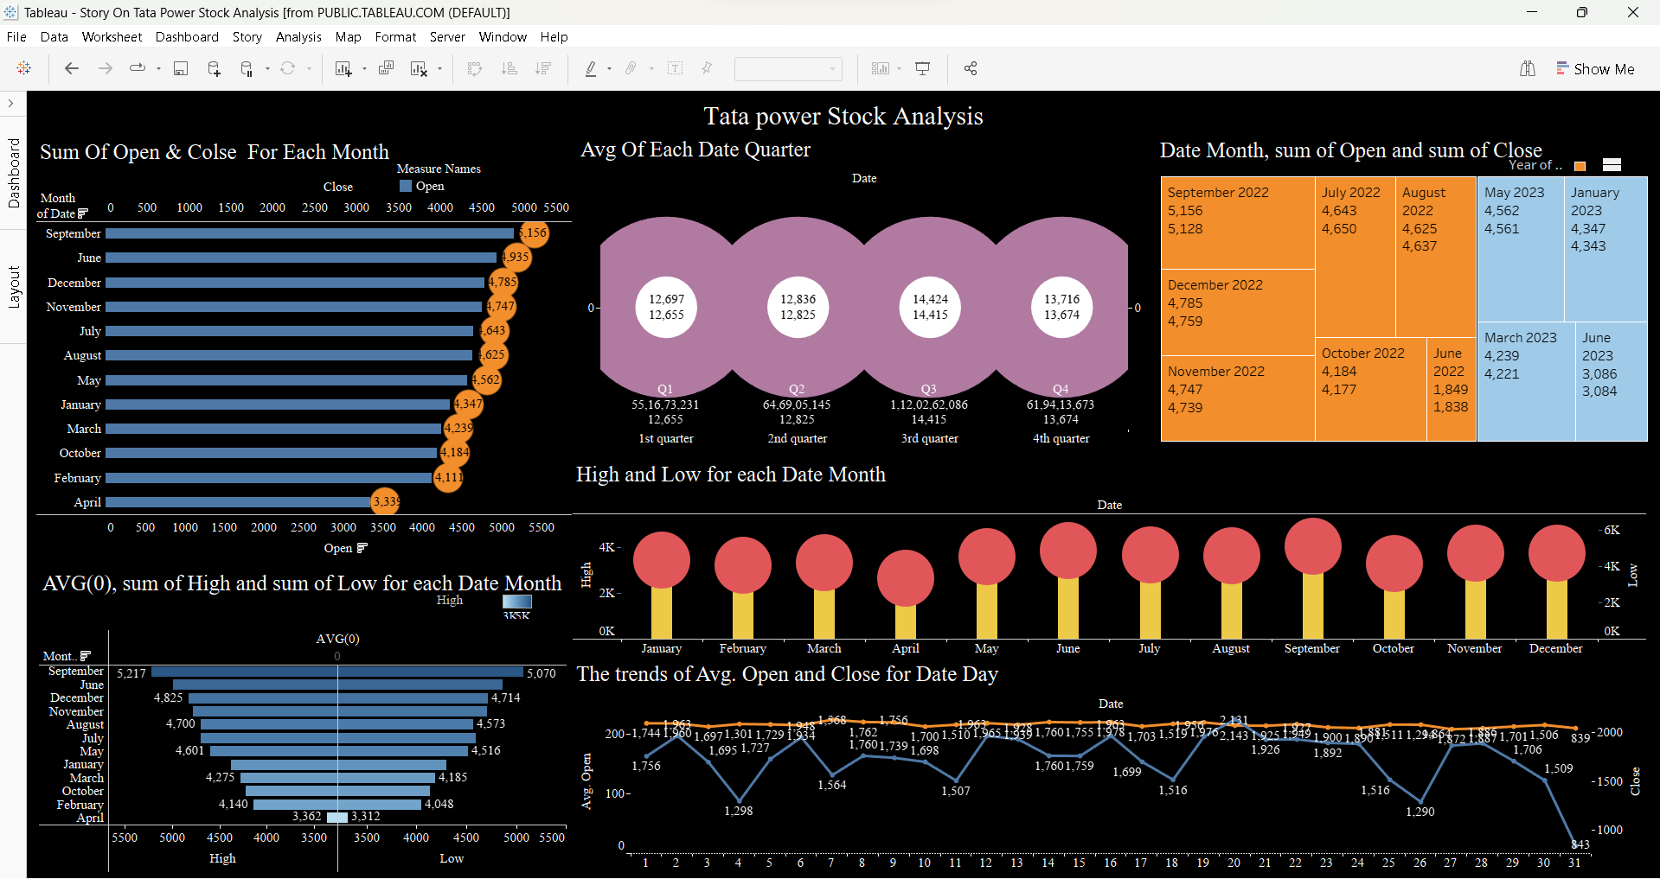

**Milestone 6: Story**

A data story is a way of presenting data and analysis in a narrative format, with the goal of making the information more engaging and easier to understand. A data story typically includes a clear introduction that sets the stage and explains the context for the data, a body that presents the data and analysis in a logical and systematic way, and a conclusion that summarizes the key findings and highlights their implications. Data stories can be told using a variety of mediums, such as reports, presentations, interactive visualizations, and videos.

**Activity:1- No of Scenes of Story**

The number of scenes in a storyboard for a data visualization analysis of the factors affecting the insights of Tata Power Stocks, will depend on the complexity of the analysis and the specific insights that are trying to be conveyed. A storyboard is a visual representation of the data analysis process, and it breaks down the analysis into a series of steps or scenes.

**Explanation video link:**[**https://dexterit-my.sharepoint.com/:v:/g/personal/sam_dexterit_onmicrosoft_com/ESsgfhXHnMxFpa6guAUdJAEB4yqZgAB9pJBBI70OjsU2nw?e=Lr6Oev**](https://dexterit-my.sharepoint.com/:v:/g/personal/sam_dexterit_onmicrosoft_com/ESsgfhXHnMxFpa6guAUdJAEB4yqZgAB9pJBBI70OjsU2nw?e=Lr6Oev)

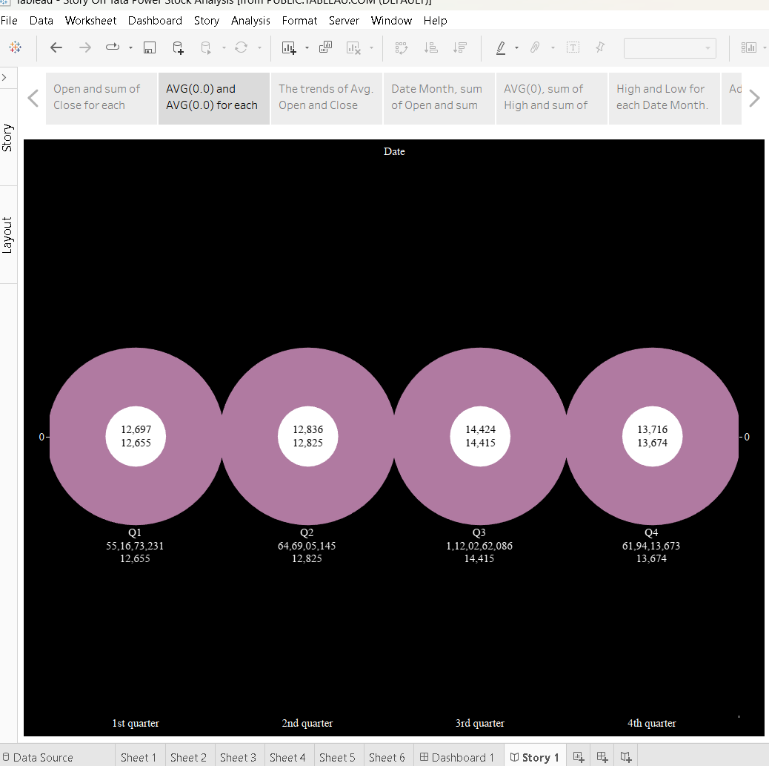

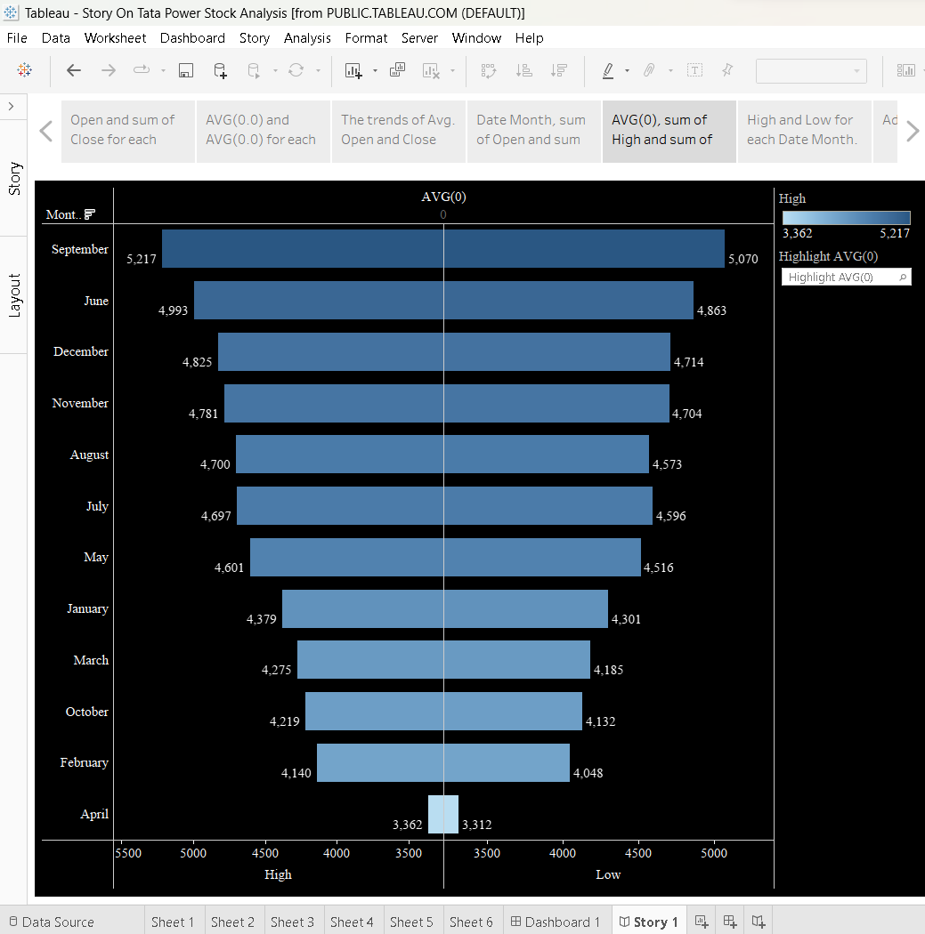

**Milestone 8: Performance Testing**

**Activity 1: Utilization of Data Filters**

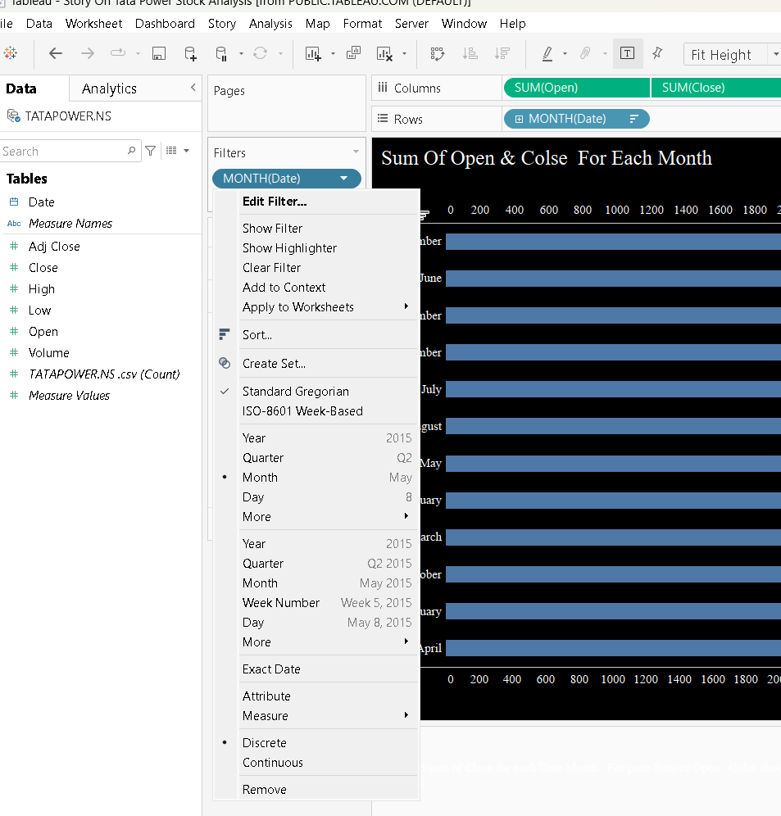

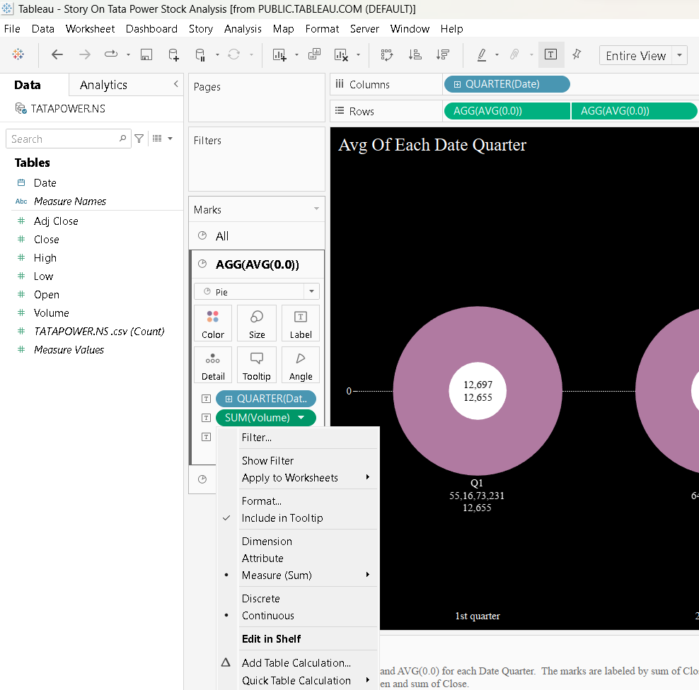

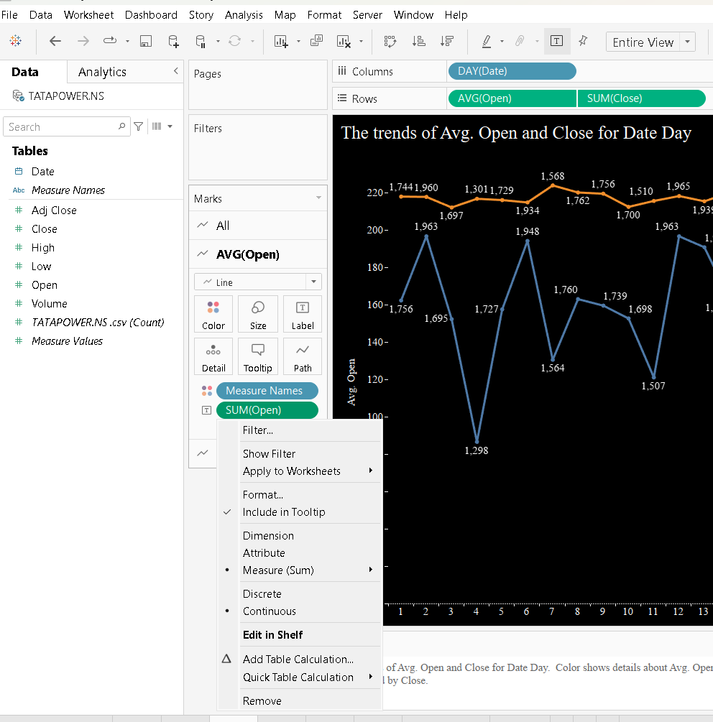

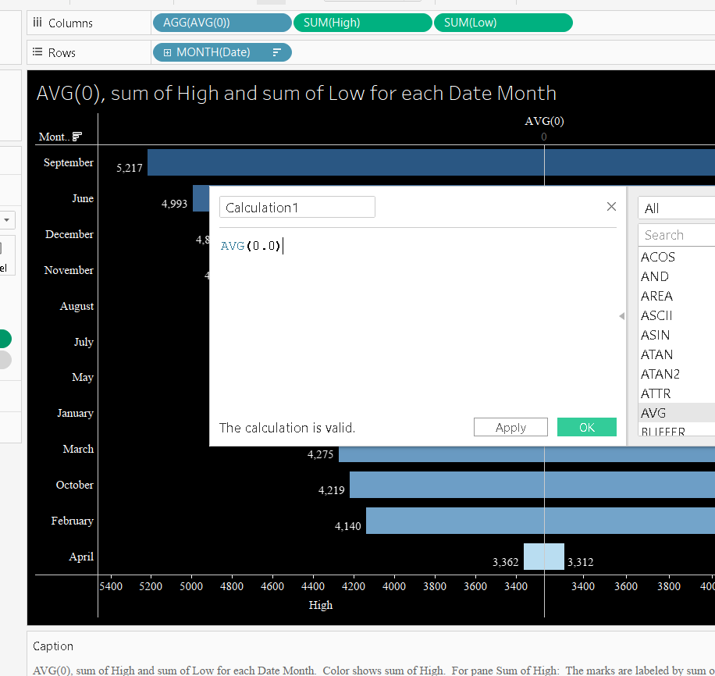

**Activity 4: No of Visualizations/ Graphs**

1. The trends of Avg. Open and Close for Date Day?
2. Date Month, sum of Open and sum of Close?
3. AVG(0), sum of High and sum of Low for each Date Month?
4. High and Low for each Date Month?
5. sum of High and sum of Low for each Date Month?
6. High and Low for each Date Month?

**Milestone 9: Web integration**

Publishing helps us to track and monitor key performance metrics, to communicate results and progress. help a publisher stay informed, make better decisions, and communicate their performance to others.

**Integrating dashboard/reports/stories to web**

Step 1: Go to **Tableau** and click on the server and publish your workbook .

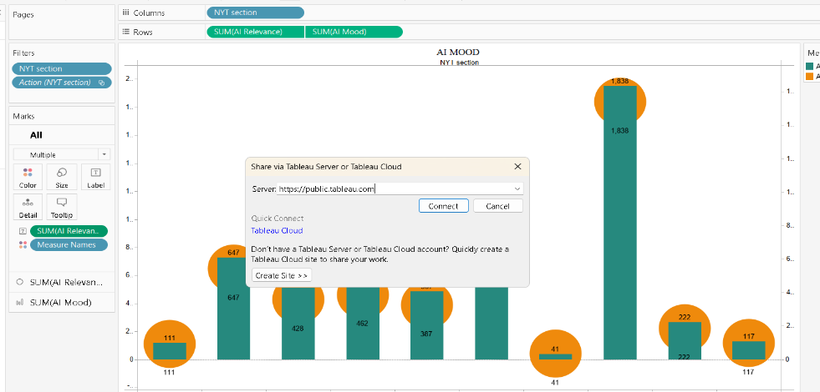

Step 2: Then enter your tableau public credentials. The sheet will be published to your tableau public account.

* Once you login into your tableau public using the credentials, the particular visualization will be published into the tableau public

**Note: While publishing the visualization to the public, the respective sheet will get published when you click on the share option.**

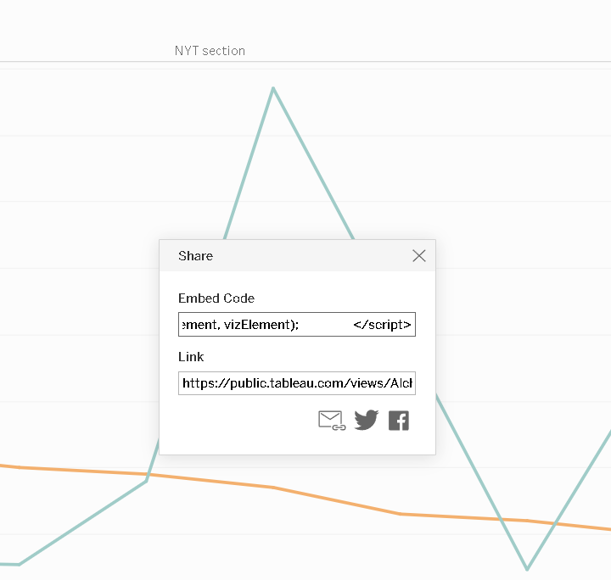Step 3: Copy the link and paste it in your html page.

**Activity 1: Dashboard and Story embed with UI**

1. You have to Publish your sheet in your tableau public account.
2. Once you publish it, get the link as shown in the video below and paste it in your html code.
3. Then the sheets are displayed.

**Explanation video link:**

[**https://dexterit-my.sharepoint.com/:v:/g/personal/sam_dexterit_onmicrosoft_com/EWnHxEmDfrJMjoPx18-4iYEBt_dVw8SQJD65AmiyJ3qMtA?e=GT6STH**](https://dexterit-my.sharepoint.com/:v:/g/personal/sam_dexterit_onmicrosoft_com/EWnHxEmDfrJMjoPx18-4iYEBt_dVw8SQJD65AmiyJ3qMtA?e=GT6STH)

**Tableau Public:-**

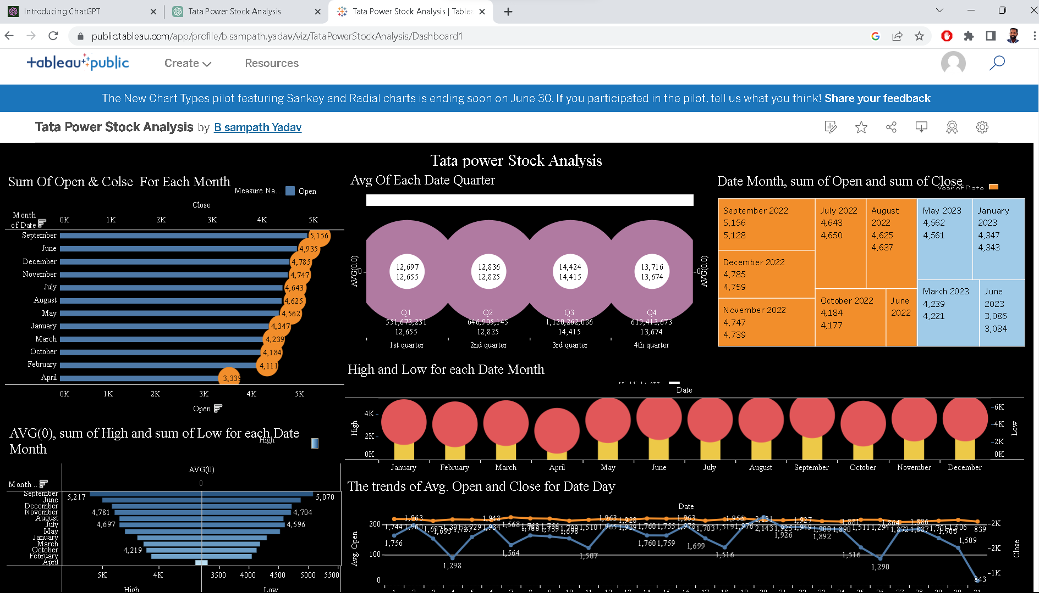

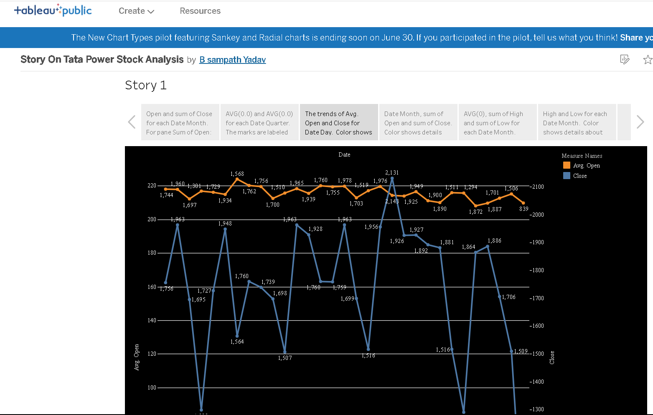

**Web Integration :-** Web data integration (WDI) is the process of aggregating and managing data from different websites into a single, homogeneous workflow. This process includes data access, transformation, mapping, quality assurance and fusion of data. Data that is sourced and structured from websites is referred to as "web data".

**Explanation video link :-**

[**https://dexterit-my.sharepoint.com/:v:/g/personal/sam_dexterit_onmicrosoft_com/EV0BiL8g6ohNoImXwLFhETIBmKmuprsVOqTWdCWtezbyYQ?e=XeelAj**](https://dexterit-my.sharepoint.com/:v:/g/personal/sam_dexterit_onmicrosoft_com/EV0BiL8g6ohNoImXwLFhETIBmKmuprsVOqTWdCWtezbyYQ?e=XeelAj)

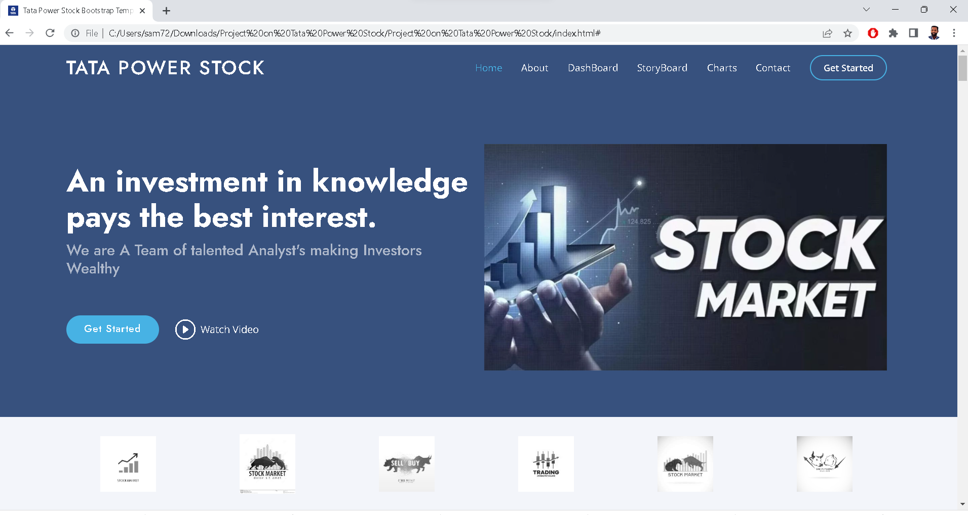

**Flask Deployment:-** Deploying a Flask application involves making it accessible and runnable on a web server, allowing users to access your application over the internet. Here's an overview of the steps involved in deploying a Flask application:

**Explanation video link :-**

[**https://dexterit-my.sharepoint.com/:v:/g/personal/sam_dexterit_onmicrosoft_com/Ed_gPGLDoZpOhQikzVNEm-UBe7u3XCi_hQMr-uLW97LBUQ?e=x69QIM**](https://dexterit-my.sharepoint.com/:v:/g/personal/sam_dexterit_onmicrosoft_com/Ed_gPGLDoZpOhQikzVNEm-UBe7u3XCi_hQMr-uLW97LBUQ?e=x69QIM)

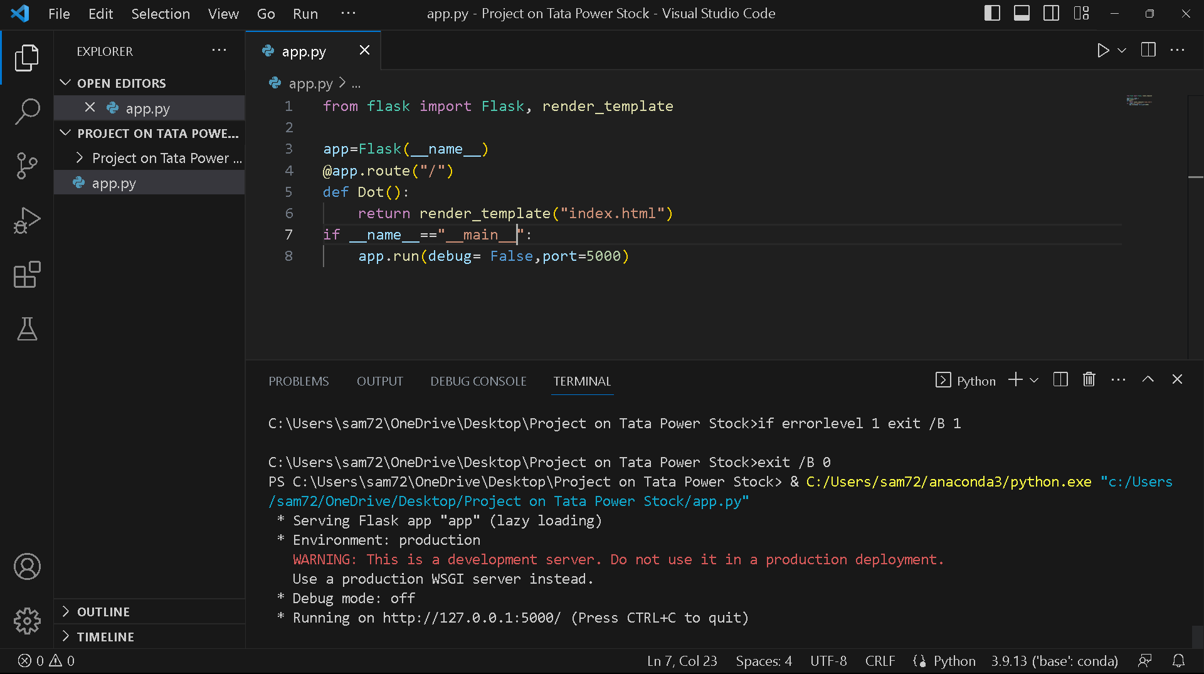

**Running on** [**http://127.0.0.1:5000/**](http://127.0.0.1:5000/%20) **(Press CTRL+C to quit)**

**The End**